ASHBY DE LA ZOUCH TOWN COUNCIL
ROOMS FOR HIRE
LEGION HOUSE, SOUTH STREET,
ASHBY, LE65 1BQ
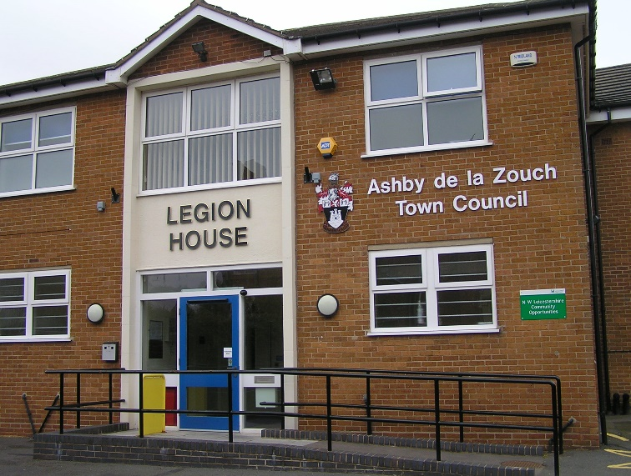
Looking for a venue for your community group or business meeting, or a local office base to meet customers in Ashby de la Zouch? Five rooms are available for hire, 7 days a week.
Town centre location with good motorway access to A42/M42. WiFi available throughout the building. Ramp access, lift and disabled toilet. Free car parking for up to nine cars, in addition to two disabled spaces.
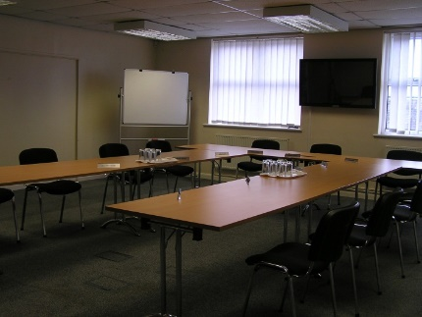
Council Chamber: holds up to 45 people with access to a small kitchen and has a 50” plasma HDMI screen. An upstairs room with lift access.

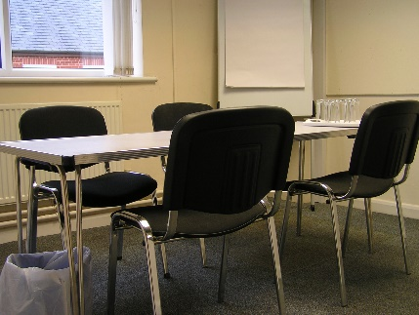
Room 1: holds 8/10 people and is upstairs with lift access.
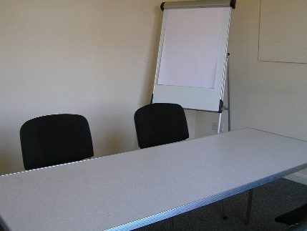
Room 2: holds 8/10 people and is upstairs with lift access.

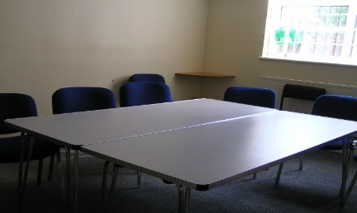
Room 4: holds 15/18 people and is on the ground floor.
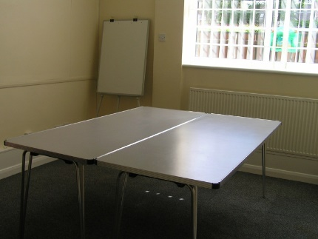
Room 5: holds 6/8 people and is on the ground floor

Rooms 1 & 2 can be booked with the Council Chamber and used as for workshops/ break out rooms or for a buffet.
Rooms 1 & 5 are ideal for smaller meetings.
All rooms can be booked by the hour 7 days a week between 9am and 10pm. Access outside these times may be available. Please speak to us.
Toilets are available on both floors. Access to kitchen is available upstairs and kettle, urn and cups can be provided in all rooms at no additional charge.
Room hire charges are:
Rooms 1,2,3 and 4:
£12.50 – 2 hours between 9:00 and 17:30
£17.50 – 4 hours between 9:00 and 17:30
£17.50 – 2 hours between 17:30 and 22:00
£22.50 – 4 hours between 17:30 and 22:00
Council Chamber
£35 – 2 hours between 9:00 and 17:30
£55 – 4 hours between 9:00 and 17:30
£45 – 2 hours between 17:30 and 22:00
£65 – 4 hours between 17:30 and 22:00
No additional charge is made for use of plasma screen (in Council Chamber), flip charts or white board, the kitchen, or for the use of a kettle or urn.
Rates are double for use on Christmas Day and Boxing Day, New Years Day and Easter Sunday.
A non refundable deposit of 25% is required at the time of booking.
Booking forms and details of current availability are available on Ashby de la Zouch Town Council website: www.ashbytowncouncil.org.uk
Or contact Karen: info@ashbytowncouncil.org.uk or 01530 416961

