Ashby de la Zouch Town Council
GENERAL DATA PROTECTION REGULATION – DATA PROTECTION POLICY.

Ashby de la Zouch Town Council, Legion House, South Street,
Ashby de la Zouch, Leicestershire LE65 1BQ.
Tel: 01530 416961
e-mail: admin@ashbytowncouncil.gov.uk.
website : www.ashbytowncouncil.gov.uk.

Twitter: @ AshbyTCouncil. Facebook: Ashbytowncouncil.

[Office open to the public from 8.30am to 1.00pm Monday to Friday excluding bank holidays.]

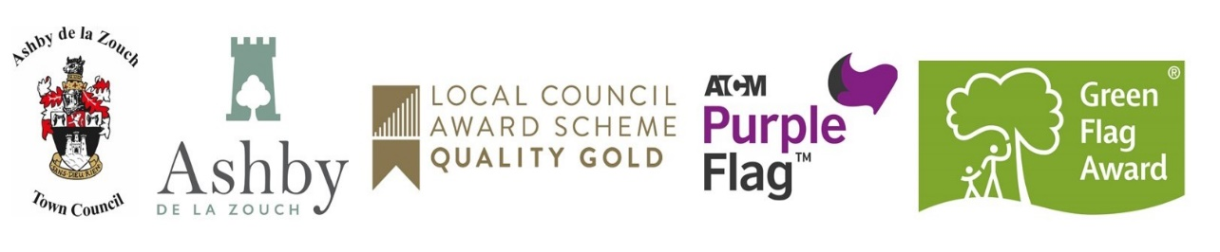

ASHBY DE LA ZOUCH TOWN COUNCIL
Data Protection Policy

- This Privacy Policy is provided to you by Ashby de la Zouch Town Council which is the data controller for your data.

- Personal data is any information about a living individual which allows them to be identified from that data (for example a name, photographs, videos, email address, or address). Identification can be by the personal data alone or in conjunction with any other personal data. The processing of personal data is governed by legislation relating to personal data which applies in the United Kingdom including the General Data Protection Regulation (the “GDPR”) and other local legislation relating to personal data and rights such as the Human Rights Act.

- The Town Council will process some or all of the following personal data where necessary to perform its tasks:

- Names, titles, and aliases, photographs;
- Contact details such as telephone numbers, addresses, and email addresses;
- Where they are relevant to the services provided by the Town Council, or where you provide them to us, we may process information such as gender, age, marital status, nationality, education/work history, academic/professional qualifications, hobbies, family composition, and dependants;
- Where you pay for activities such as use of a Town Council facility, financial identifiers such as bank account numbers, payment card numbers, payment/transaction identifiers, policy numbers, and claim numbers;
- The personal data we process may include sensitive or other special categories of personal data such as criminal convictions, racial or ethnic origin, mental and physical health, details of injuries, medication/treatment received, political beliefs, trade union affiliation, genetic data, biometric data, data concerning and sexual life or orientation.

- The Town Council will comply with data protection law. This says that the personal data we hold about you must be:

- Used lawfully, fairly and in a transparent way;
- Collected only for valid purposes that we have clearly explained to you and not used in any way that is incompatible with those purposes;
- Relevant to the purposes we have told you about and limited only to those purposes;
- Accurate and kept up to date;
- Kept only as long as necessary for the purposes we have told you about;
- Kept and destroyed securely including ensuring that appropriate technical and security measures are in place to protect your personal data to protect personal data from loss, misuse, unauthorised access and disclosure.

- This section provides information about the third parties with whom the council may share your personal data. These third parties have an obligation to put in place appropriate security measures and will be responsible to you directly for the manner in which they process and protect your personal data. It is likely that we will need to share your data with some or all of the following (but only where necessary):

- Our agents, suppliers and contractors. For example, we may ask a commercial provider to publish or distribute newsletters on our behalf, or to maintain our database software;
- On occasion, other local authorities or not for profit bodies with which we are carrying out joint ventures e.g. in relation to facilities or events for the community.

- You have the following rights with respect to your personal data:
When exercising any of the rights listed below, in order to process your request, we may need to verify your identity for your security. In such cases we will need you to respond with proof of your identity before you can exercise these rights.
- The right to access personal data we hold on you;
- The right to correct and update the personal data we hold on you;
- The right to have your personal data erased;
- The right to object to processing of your personal data or to restrict it to certain purposes only;
- The right to data portability;
- The right to withdraw your consent to the processing at any time for any processing of data to which consent was obtained;
- The right to lodge a complaint with the Information Commissioner’s Office.
For more information, please see our Subject Access Request Policy.
- Transfer of data abroad.
Any personal data transferred to countries or territories outside the European Economic Area (“EEA”) will only be placed on systems complying with measures giving equivalent protection of personal rights either through international agreements or contracts approved by the European Union. Our website is also accessible from overseas so on occasion some personal data (for example in a newsletter) may be accessed from overseas.
- Further processing.
If we wish to use your personal data for a new purpose, not covered by this Privacy Policy, then we will provide you with a Privacy Notice explaining this new use prior to commencing the processing and setting out the relevant purposes and processing conditions. Where and whenever necessary, we will seek your prior consent to the new processing.
- We keep this Privacy Policy under regular review.

The next review is due to take place: January 2022

Please contact us if you have any questions about this Privacy Policy or the personal data we hold about you or to exercise all relevant rights, queries or complaints at: admin@ashbytowncouncil.gov.uk, telephone: 01530 416961

Adopted by the Town Council at its meeting on Monday 25th June 2018.
Reviewed and re-adopted on Monday 13th January 2020; 11th January 2021; 10th January 2022;16th January 2023.

