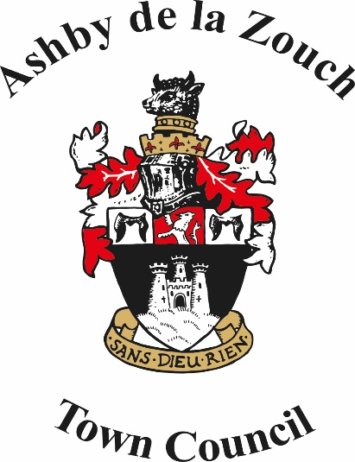

Ashby de la Zouch Town Council

DIGNITY AT WORK POLICY.

Ashby de la Zouch Town Council, Legion House, South Street,
Ashby de la Zouch, Leicestershire LE65 1BQ.
Tel: 01530 416961
e-mail: admin@ashbytowncouncil.gov.uk.
website : www.ashbytowncouncil.gov.uk.

Twitter: @ AshbyTCouncil. Facebook: Ashbytowncouncil.

[Office open to the public from 8.30am to 1.00pm Monday to Friday excluding bank holidays.]

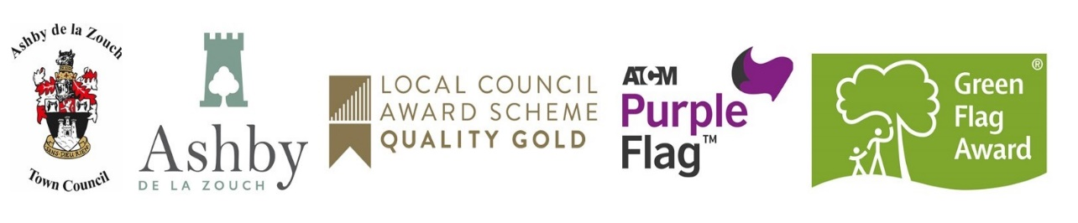

DIGNITY AT WORK POLICY.

1. Purpose and Scope.

Ashby de la Zouch Town Council will not tolerate bullying or harassment of any of its employees by elected members, other employees, contractors, visitors to the Town Council or members of the public. The Town Council is committed to the elimination of any form of intimidation in the workplace.

This policy reflects the spirit in which the Town Council intends to undertake all of its business and outlines the specific procedures available to all employees in order to protect them from bullying and harassment. It should be read in conjunction with the Town Council’s policies on Grievance and Disciplinary handling as set out in the Employees Handbook and the Code of Conduct for elected members. The Town Council will issue this policy to all employees as part of their induction and to all newly elected members.

Everyone who comes into contact with the Town Council has a responsibility to ensure that their conduct towards others does not harass or bully or in any way demean the dignity of others. If unacceptable behaviour is observed then each individual can challenge the perpetrator and ask them to stop. Effective management of performance will usually include feedback based on objective evidence with dialogue occurring on a face to face basis in confidential surroundings.

Bullying and harassment is most likely to be complained about when individual elected members or members of the public criticise Town Council employees, often without objective evidence and in environments which are open to the public such as Town Council meetings or by way of blogs, Facebook comments, Twitter, other social media (“cyber bullying”).

2. Definitions.
Bullying:
“Persistent, offensive, abusive, intimidating or insulting behaviour, abuse of power or unfair penal sanctions which makes the recipient feel upset, threatened, humiliated or vulnerable, which undermines their self-confidence and which may cause them to suffer stress."
Harassment:

“unwanted conduct that violates a person’s dignity or creates an intimidating, hostile, degrading, humiliating or offensive environment.”

This usually covers, but is not limited to, harassment on the grounds of sex, marital status, sexual orientation, race, colour, nationality, ethnic origin, religion, belief, disability or age. Bullying and harassment are behaviours which are unwanted by the recipient. They are generally evidenced by a pattern of conduct, rather than being related to one-off incidents.

Bullying and harassment in the workplace can lead to poor morale, low productivity and poor performance, sickness absence, mental health issues, lack of respect for others, turnover, damage to the Town Council’s reputation and ultimately, legal proceedings against the Town Council including payment of legal fees and potentially unlimited compensation.

3. Examples.

Examples of unacceptable behaviour are as follows (this list is not exhaustive):

Spreading malicious rumours, insulting someone, ridiculing or demeaning someone, exclusion or victimisation, unfair treatment, overbearing supervision or other misuse of position or power, unwelcome sexual advances, making threats about job security, making threats of physical violence against a person or their family, deliberately undermining a competent worker by overloading work and/or constant criticism, blaming a person for others’ mistakes, preventing an individual’s promotion or training opportunities.

Bullying and harassment may occur face-to-face, in meetings, through written communication, including electronic communication such as e-mail or on social media, by telephone or through automatic supervision methods. It may occur on or off work premises, during work hours or non-work time.

4. The legal position.

Councils have a duty of care towards all their workers and liability under common law arising out of the Employment Rights Act 1996 and the Health and Safety at Work Act 1974. If an employer fails to act reasonably with regard to this duty of care by allowing bullying or harassment to continue unchallenged an employee may decide to resign and claim ‘constructive dismissal’ at an Employment Tribunal.

Under the Equality Act 2010 bullying or harassment related to one of the protected characteristics covered by the Act (age, gender, marital status, sexual orientation, race, religion, belief, colour, disability) can be considered unlawful discrimination which could lead to an Employment Tribunal claim for discrimination against the corporate employer, the council and the perpetrator(s) as individual named Respondents.

The legal definition of “Third Party Harassment” has been introduced which makes the employer vicariously liable for harassment from other parties such as parishioners, contractors etc and it must take reasonable steps to manage such situations which could include seeking legal redress on behalf of an employee or member of the council.

In addition, the Criminal Justice and Public Order Act 1994 and Protection from Harassment Act 1997 created a criminal offence of harassment with a fine and/or prison sentence as a penalty and a right to damages for the victim. A harasser may be personally liable to pay damages if a victim complains to an Employment Tribunal on the grounds of discrimination.

The 1997 Act was originally designed to assist in stalking situations but case law has demonstrated that it can be relevant to employment disputes, for instance: employers can be vicariously liable for harassment received in the workplace, that the conduct is viewed as ‘serious’, or ‘oppressive and unacceptable’, that a ‘course of conduct’ needs to be established but that this can link incidents which are separated by long time periods and that damages for personal injury and distress can be awarded under the Act.

5. Process for dealing with complaints of Bullying and Harassment.

Informal approach

Someone who feels they are being bullied or harassed should try to resolve the problem informally, in the first instance. It may be sufficient to explain to the person(s) involved in the unwanted behaviour, or an intermediary, that their conduct is unacceptable, offensive or causing discomfort. Anyone concerned about being bullied or harassed is encouraged to maintain a record of the incidents.

Formal approach.

Employees.

Where an employee of the Town Council feels unable to resolve the matter informally any complaint about harassment or bullying can be raised confidentially and informally, initially with the Town Clerk. In the case of bullying or harassment of the Town Clerk s/he should raise this with the Leader of the Town Council or the Chairman in the first instance.

It may be appropriate for the complaint to be put in writing after the initial discussion, as this will enable the formal Grievance Procedure to be invoked. The member of staff will be expected to provide evidence of the conduct about which s/he is complaining.

The procedure for this is set out in the Employees’ Handbook.

Others.

Anyone else who has business with the Town Council, other than an employee, who feels s/he is being bullied or harassed should raise their complaint with the Town Clerk. The complaint will be investigated and a meeting held, if necessary, to discuss the facts and recommend the way forward.

At all times the confidentiality of the complaint will be of paramount importance in order to maintain trust in the process. Details of the complaint will not be shared with the Town Council without prior approval by the aggrieved. The Town Council will undertake not to victimize the complainant for raising the complaint once the appropriate dispute resolution process has been concluded.

Disciplinary Action.

Following a Grievance Hearing or investigation into allegations of bullying or harassment a full report will be made to all parties and this may result in disciplinary action being taken against the perpetrator of the alleged action/behaviour.

For an employee found to have been bullying/harassing others this will follow the Town Council’s Disciplinary procedure and will be treated as Gross Misconduct.

For members whom the Town Council reasonably believe have been bullying or harassing another person(s) whilst undertaking Town Council activities the action taken must be reasonable and in some cases counselling or training in appropriate skill areas e.g. inter-personal communication, assertiveness, chairmanship etc., may be appropriate.

The range of disciplinary sanctions available to the Town Council, where a member has been involved in bullying/harassment include: admonishment and an undertaking not to repeat the process, removal of opportunities to further harass/bully, banning from committees of the Town Council and representation on any outside bodies, a referral under the Code of Conduct to the Monitoring Officer.

There may also be a referral to the Police under the Protection from Harassment Act 1997, or a claim to an Employment Tribunal for Third Party harassment (for harassment relating to one of the protected characteristics under the Equality Act). This list is not exhaustive.

False or malicious allegations of harassment or bullying which damage the reputation of a fellow employee/member will not be tolerated and will be dealt with as serious misconduct under the Disciplinary Procedure and/or a referral to the Monitoring Officer.

6. Penalties.

Bullying and harassment by any employed persons of one another can be considered examples of serious misconduct which will be dealt with through the Disciplinary Procedure at Gross Misconduct level and may result in summary dismissal from the Town Council.

If elected members are bullying or harassing Town Council employees, contractors, fellow councillors, or members of the public a referral to the Monitoring Officer as a contravention of the Code of Conduct may be an initial appropriate measure. If this is unsuccessful then referral to the Town Council’s solicitors may follow.

If an employee is experiencing bullying or harassment from a member of the public the Town Council will act reasonably in upholding its duty of care towards its own employees. Such complaints will be taken seriously and will be pursued with the third party concerned, exercising whatever sanctions are available. In some cases harassment can constitute a criminal offence and the Town Council will take appropriate legal advice and action if such an issue arises.

A review of the policy shall be undertaken as appropriate and necessary amendments will be undertaken by the Town Clerk and reported to the Town Council for approval.

This policy was adopted by the Ashby de la Zouch Town Council at its meeting on 9th December 2013.
Reviewed and re-adopted 24th September 2018, 7th October 2019, 12th October 2020, 11th October 2021; 10th October 2022.

